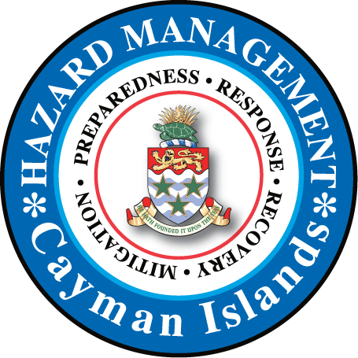

Family Emergency Plan
Family Name:
Family phone numbers:
Name | Phone | Alternative phone | Email

Family medical conditions:
Medication | Time required to take medication | Doctor’s name | Doctor’s phone
Friends and neighbors:
Name | Phone | Alternative phone | Email

Our families’ off Island contacts:
Name | Phone | Address | Email

Emergency numbers:
Agency | Phone | Website | Email
Police
Fire
Medical
Veterinarian
CUC
Immigration
Telecom Provider
Water Authority
School

Other important numbers:
Name | Phone | Alternative phone | Email

1) In a HURRICANE, we plan to: (tick which one best applies)
- Evacuate the island
- Stay at home
- Go to a Public Shelter (if so, which one)
- Go to a Private Shelter (if so, which one)
- Stay with a friend
- We will decide depending on the circumstances but discuss all options (in ‘Alert’ phase)

1b) Our home is:
- In a low lying flood prone area
- Is …….. ft above sea level
- There are lots of trees and potential for flying objects directly outside our home
- Is a single story home
- Is made of wood
- Has lots of glass windows
- Other vulnerabilities………………………………………..

2) In an EARTHQUAKE/ TSUNAMI/FIRE, if split up we plan to:
- CONTACT EACHOTHER (how):

- REUNITE (where):

- If at School:

- If at home:

- If unknown:

In the event of a TSUNAMI alert-in relation to your HOME/ SCHOOL/ WORKPLACE etc., where is the closest high ground or accessible strong multi –story building and how long would it take to get there by car/ foot?

3) FIRE Evacuation plan for our household:
Exit plan (list for each room):

Outside meeting location (Primary):

Alternative Outside meeting location (if Primary is inaccessible):

EVACUATION PLAN SUMMARY:

People:

Critical Personal items:

Pets:

SUMMARY
- We know the dangers and what to expect from a hurricane

- Our family has an Emergency Supplies kit

- Our Family has a “Grab and Go” kit

- We have secured all essential documents in a waterproof bag and made photo copies/ scanned to email

- We have a plan for our pets

- We have taken measures to secure our home

- We have chosen a Safe Shelter

- We know what to do when a storm threatens and each hurricane phase (Alert/ Watch/ Warning / All Clear)

- Our family have discussed the emotional aspects of a storm/ other emergency

- We have discussed what we will do and safety measures post-Hurricane

“Know you Risks, Make a Plan, Get a Kit, Stay Informed!”

