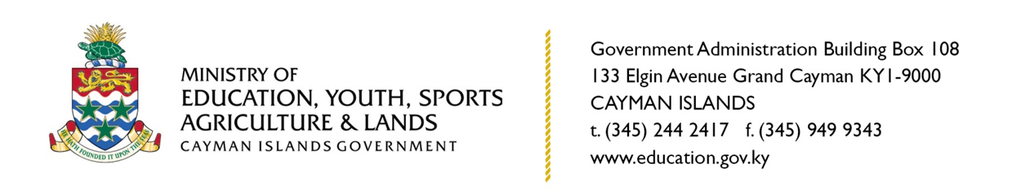

**PRESS RELEASE**

**Application Deadline for Overseas Scholarships Approaching**

**Grand Cayman, Cayman Islands, 08 January 2021.**The Ministry of Education’s Scholarship Secretariat invites all eligible Caymanians interested in pursuing tertiary studies overseas for the 2021-2022 academic year, to submit their applications for overseas government scholarships before the upcoming deadline of 31 January 2021.

“Despite the impact of COVID-19 on the world, the Education Council was still able to award educational scholarships for applicants to pursue overseas degree programmes, with many commencing with an online format. The Education Council has taken into account the impact COVID-19 has had on all of our students and continued to provide support not only through financial means but considerations of policies where needed,” comments Manager of the Scholarship Secretariat Dr. Shari Smith.

The overseas scholarship for undergraduate degree awards a maximum of CI $20,000.00 per annum for up to four years per successful applicant, whereas the post-graduate award is up to $25,000 per annum. Interested applicants are asked to apply and find more details about the application process online by visiting www.education.gov.ky/scholarships.

A total of 157 new overseas scholarships were issued to successful applicants in 2020. 124 of those scholarships were awarded to applicants pursuing their bachelor’s degree, and 33 were awarded to students pursuing post-graduate degrees.

The period of application opened on 15 November 2020.

-ENDS-

MEDIA CONTACT:

STACEY-ANN ANDERSON

COMMUNICATIONS OFFICER

MINISTRY OF EDUCATION, YOUTH, SPORTS, AGRICULTURE AND LANDS

E: staceyann.anderson@gov.ky